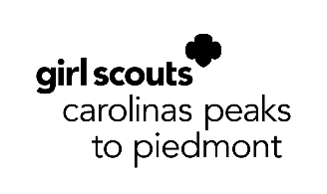
Girl Scout Silver Award
Photo & Press Release
This form must be completed by the Silver Award candidate and each individual who appears in any photographs, videos, or audio recordings made during her Silver Award project.

I, , consent that the photographs, videos, and/or audio recordings of me may be used by Girl Scouts Carolinas Peaks to Piedmont and its assignees or successors in whatever way they desire, including television and electronic media. Furthermore, I consent that such photographs, films, recordings, plates, and tapes are their property, and they shall have the right to sell, duplicate, reproduce, and make other uses of such photographs, films, recordings, plates, and tapes as they may desire, free and clear of any claims whatsoever on my part.

I give my consent on (day) of (month), (year).

Participant’s Printed Name:
Signature of Participant: ________________________________________________________

Parent or Guardian Printed Name:
Signature of Parent or Guardian: _________________________________________________
Parent or guardian signature needed for all participants under 18 years old.

