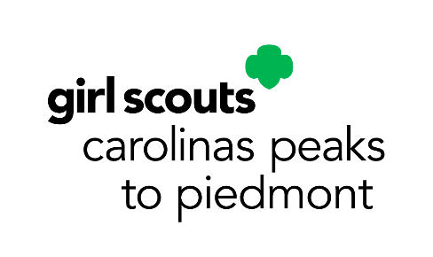
April Service Unit Meeting Agenda
Service Unit _________________________
Meeting Date: __________________________________

Council-wide Announcements:
- See accompanying PowerPoint
Upcoming Council-wide Dates and Events:
- Annual Meeting: April 25, 2026 (Thomasville)
- Highest Awards Girl Gala: May 16, 2026 (Dobson)
- All Council Calendar Program Events: https://www.girlscoutsp2p.org/en/discover/activities/event-calendar.html
Our SU Membership Update:
- _______ New Girls as of _________ (_______% to our goal)
- _______ Renewed Girls as of _________ (_______% to our goal)
- _______ New Troops as of _________ (_______% to our goal)
SU Banking Specialist Report:
- We have _______________ in our SU Account as of _______________.
- Income:
- Expenses:
Our SU Announcements:

Upcoming SU Dates and Events:

