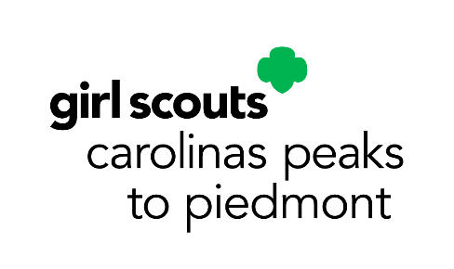
December Service Unit Meeting Agenda
Service Unit _________________________
Meeting Date: __________________________________

Council-wide Announcements:
- Rallyhood Updates
- Fall Product Program Updates
- GS Cookie Program Updates
- Board Approved National Awards
- Retail Updates
Upcoming Council-wide Dates and Events:
- Council Calendar Program Events: https://www.girlscoutsp2p.org/en/discover/activities/event-calendar.html
- October 1- December 15: SU’s Elect Delegates
- See PowerPoint slides for full list of programs and links to register
Our SU Membership Update:
- _______ New Girls as of _________ (_______% to our goal)
- _______ Renewed Girls as of _________ (_______% to our goal)
- _______ New Troops as of _________ (_______% to our goal)
SU Banking Specialist Report:
- We have _______________ in our SU Account as of _______________.
Our SU Announcements:

Upcoming SU Dates and Events:

