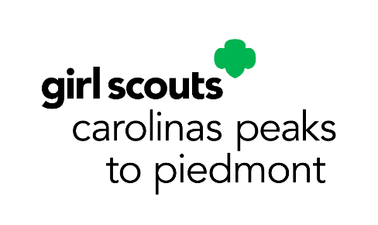
May Service Unit Meeting Agenda
Service Unit _________________________
Meeting Date: __________________________________

Council-wide Announcements:
- See accompanying PowerPoint
Upcoming Council-wide Dates and Events:
- Highest Awards Girl Gala: May 16, 2026 (Dobson)
- G.E.O. Event at Wet n’ Wild: June 6, 2026 (Greensboro)
- Council-wide Bridging Ceremony and Family Fun Day: June 13, 2026 (KPC)
- All Council Calendar Program Events: https://www.girlscoutsp2p.org/en/discover/activities/event-calendar.html
Our SU Membership Update:
- _______ New Girls as of _________ (_______% to our goal)
- _______ Renewed Girls as of _________ (_______% to our goal)
- _______ New Troops as of _________ (_______% to our goal)
- _______ Spring Renewal Girls as of _________ (_______% to our goal)
- _______ Extended Year Girls as of _________ (_______% to our goal)

SU Banking Specialist Report:
- We have _______________ in our SU Account as of _______________.
- Income:
- Expenses:
Our SU Announcements:

Upcoming SU Dates and Events:

