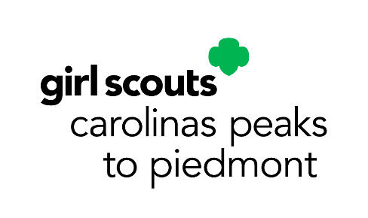
September Service Unit Meeting Agenda
Service Unit _________________________
Meeting Date: __________________________________

Council-wide Announcements:
- Rallyhood
- Delegate Process
- Property Updates
- Fall Product Program Updates
Upcoming Council-wide Dates and Events:
- Council Calendar Program Events: https://www.girlscoutsp2p.org/en/discover/activities/event-calendar.html
- Circle C Fall Events: https://www.girlscoutsp2p.org/en/discover/activities/events.html?q=circle%20c
- September 12: Media Girls application window closes
- September 15: Fall Product Program Kicks Off
- September 18: Rallyhood Admin Training
- September 20: KPC 80th Birthday (registration deadline: September 8)
- September 26-28: Leaderee (registration deadline: September 8)
- October 1- December 15: SU’s Elect Delegates
- October 3-5: Trainfest (registration deadline: September 12)
- October 11: International Day of the Girl events (registration deadline: October 6)
- October 18-19: Council Wide Camp Out (registration deadline: October 8)
Our SU Membership Update:
- _______ New Girls as of _________ (_______% to our goal)
- _______ Renewed Girls as of _________ (_______% to our goal)
- _______ New Troops as of _________ (_______% to our goal)
SU Banking Specialist Report:
- We have _______________ in our SU Account as of _______________.
Our SU Announcements:

Upcoming SU Dates and Events:

