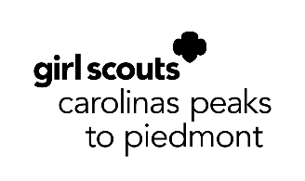

Girl Scout Gold Award

Community Agency Agreement
The Girl Scout Gold Award is the highest award in Girl Scouting. A girl who earns the Girl Scout Gold Award completes several requirements, all which promote community service, personal and spiritual growth, positive values, and leadership skills. The Gold Award project is the culmination of this extensive work and must be of outstanding quality. On behalf of Girl Scouts Carolinas Peaks to Piedmont and the Gold Award Committee, we wish to extend our sincere thanks for your support of the Gold Award and Girl Scouts.

Girl Name: Troop #:
Address: City: Zip Code:
Email: Phone:
Troop Leader/Volunteer Name:
Project Title:
Project Summary:

Gold Award Project Advisor:
Email: Phone:
Project Advisor’s Signature: _______________________________________________ Date: ____________

Name of Community Agency:
Contact Person: Title:
Email: Phone:
Contact Person’s Signature: ___________________________________________ Date: ____________

