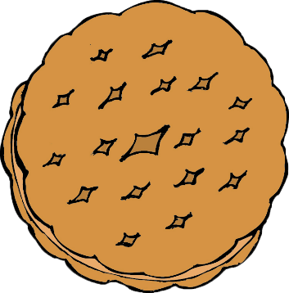



Girls grades K-5 are invited to join us for a Girl Scout Cookie Rally!

7-8 p.m.

August 10, 2020

Location Name

Address

Parents & Caregivers, you’re invited too!

Get more information and register at

(add link or contact info)



It’s Girl Scout Cookie Time!